3.6 Image Acquisition and Processing System
The hardware devices selection foreseen in UWAVS hardware architecture is based on devices available in the Fast Controller catalog [28]. The data acquisition of the cameras will be performed by a DAQ MTCA chassis and the data processing will be performed on CPU and GPU in a DAQ Fast Controller.

3.6.1 DAQ MTCA.4 I/O chassis

The MTCA-12-P-ML reference is foreseen. It implements 12 slots, while only 2 cameras have to be controlled per chassis. However, this model has the benefit of proposing fan and power supply redundancy.

Figure 1 : DAQ MTCA.4 I/O Chassis.

Two configurations were proposed at PDR level:
- The first one consisted in managing both IR cameras by the same chassis, and consequently both visible cameras are managed by the other one. This configuration was fully relevant for bi-color measurements.
- The second configuration had 1 IR and 1 Visible camera per chassis. This configuration was targeting the redundancy of the visible and IR combination.
For FD phase, bi-color measurements are not required anymore, which would make the first option less relevant. Furthermore, some camera specifications have changed, i.e. the 2 cameras are of different models. In consequence, the highlighted advantages of each configuration are not relevant anymore. Therefore, we have chosen to design the first configuration in order to leave the door open to bi-color measurements if the topic is re-envisioned in the future (without adding a Supervisory Fast Controller to the designed hardware).

3.6.2 DAQ Grade HDEC PC computers
The ID1812-B-004/ITER reference is foreseen because it embeds a GPU board considering that some algorithms will be implemented on GPU in order to fulfill latency requirements.

Figure 2 : HDEC PC Computer.

3.6.3 10GigE frame grabbers
During the design phase, a contribution of a Data Acquisition prototyping activity was the development of a 10GigE frame grabber. This 10GigE frame grabber is based on the Image Reference System and is compatible with CODAC framework.

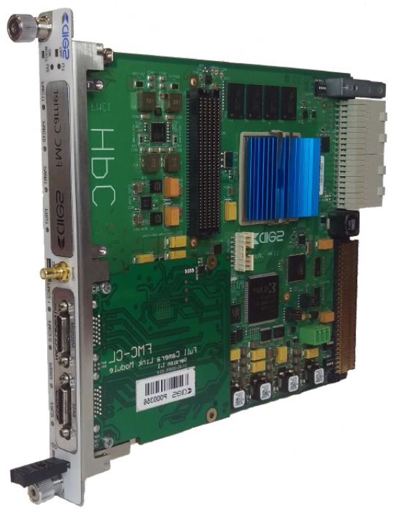
Figure 3 : 10GigE frame grabber.

3.6.4 Power Supplies
Devices dedicated to Image acquisition shall be supplied: the cameras (4), their media converters (4) and the camera trigger signal amplifiers (4).
The IR cameras and their related media converters will be supplied by NEX0 power supplies. Nevertheless, a power supply is required in the camera cubicle to supply the remaining listed devices.
For this purpose, we propose to use a Caen SY5527 power supply chassis equipped with:
- Two A2553 (A) modules to output 0-24 V signals,
- A A4528 CPU in Advanced Version to have access to additional connectors allowing to check some signals directly at cubicle level,
- A A5534 LCD Touchscreen to ease failure investigation if needed.
The first A2553 will be dedicated the visible cameras whereas the second one will supply the camera trigger signal amplifiers.
Figure 4 : Caen power supply for camera

3.6.5 Circuit breakers
Schneider Electric circuit breakers 2P, 6A, C curve, 230 VAC (A9F77206) are foreseen for the Fast controllers and the MTCA chassis. A Schneider Electric circuit breaker 2P, 10A, C curve, 230 VAC (A9F77210) is foreseen for the Power Supply.

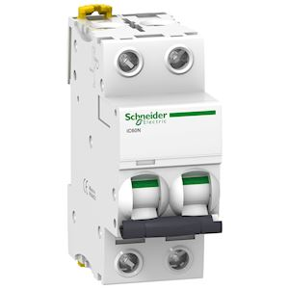
Figure 5 : Schneider Circuit Breaker

3.6.6 IR Cameras
At PDR level, two large FOV IR cameras were required, especially for bi-color measurements. Meanwhile, it was stated that bi-color measurements were not anymore on the stack, and that a large FOV IR camera and a High-Speed one will allow the I&C Plant System to cover, as far as possible, the Measurements to be performed.
For the large FOV IR camera, the Infratec ImageIR 10300 model, already proposed at PDR, is always the camera model used in the Final Design. Concerning the High-Speed IR camera, we preconize to use a camera model belonging to the same family (Infratec ImageIR) for implementation and maintenance reasons. In this context, the Infratec ImageIR 8300hs model has been selected

Table 11. Technical Specifications of Infratec ImageIR 10300
Technical Specifications
Spectral range | (3.6 … 4.9) µm
Pitch | 10 µm
Detector | InSb
Detector format (IR pixels) | (1,920 x 1,536)
Image recording principle | Snapshot
Readout mode | ITR / IWR
Aperture | f/2.0
Detector cooling | Stirling cooler
Temperature measuring range | (-40 … 1,200) °C, up to 3,000 °C
Measurement accuracy | ±1 °C or ±1 %
Temperature resolution at 30 °C | Better than 0.035 K/0.0022K in high-speed mode
Frame rate | Up to 113 / 216 / 396 / 1,915 Hz  High-speed mode: up to 400 / 692 / 1,088 / 2,493 Hz
Focus | Manual, motorized or automatic
Dynamic range | 13 bit
Integration time | (1 … 20,000) µsecs
Rotating aperture wheel and filter | Up to 7 positions
Interfaces | 10GigE, HDMI
Trigger | 4 IN/2 OUT, yes
Trigger Input Level | TTL
Analog Signals, IRIG-B | 2 IN/2 OUT, yes
Power Supply | 24 V DC, wide-range power supply (100 …240) V DC
Window mode | Yes

Table 12. Technical Specifications of Infratec ImageIR 8300hs
Technical Specifications
Spectral range | (1.5 … 5.5) µm
Pitch | 25 µm
Detector | InSb
Detector format (IR pixels) | (640 x 512)
Image recording principle | Snapshot
Readout mode | IWR
Aperture | f/2.0
Detector cooling | Stirling cooler
Temperature measuring range | (-40 … 1,700) °C, up to 3,000 °C
Measurement accuracy | ±1 °C or ±1 %
Temperature resolution at 30 °C | Better than 0.02 K
Frame rate | Up to 1,105 / 1,957 / 3,731 / 30,330 Hz
Focus | Manual, motorized or automatic
Dynamic range | Up to 14 bit
Integration time | (0.5 … 20,000) µsecs
Rotating aperture wheel and filter | Up to 7 positions
Interfaces | 10GigE, HDMI
Trigger | 4 IN/2 OUT, yes
Trigger Input Level | TTL
Analog Signals, IRIG-B | 2 IN/2 OUT, yes
Power Supply | 24 V DC, wide-range power supply (100 …240) V DC
Window mode | Yes

3.6.7 Visible cameras
The High Resolution Visible camera proposed at PDR was the Emergent EMV HT-12000 model. This model is now obsolete. Thus, in replacement, the Baumer VQXT-120M.HS model is proposed. This model embeds the same sensor as the Emergent camera.

Table 13. Technical Specifications of Baumer VQXT-120M.HS (High Resolution Visible camera)
Technical Specifications
Resolution | (4, 096 x 3, 068)
Sensor | ams (CMOSIS) CMV12000
Pixel size | 5.5 µm (square)
Frame rate | 92 fps
Dynamic Range | 42.9 dB
Dark noise (s) | 14.09 e-
Saturation | 7, 847 e-
SNR | 38.9 dB
Quantum efficiency η | 36.2 % @ 536 nm
Trigger Mode | Hardware, Software
Trigger Input Level | 11-30V
Digital Output | 8 bit
Interfaces | 10GigE, 10GBaseT
Monochrome modes | Mono
Dimensions | 99.15 x 70 x 70 mm
Weight | 640g
Power Requirements | 12 / 24 V
Operating Temperature | +5 – 65°C

The Mikrotron Eosens 4CPX6 camera is now not produced anymore. Therefore, the Baumer VLXT-17M.I is chosen, as a substitute, to be the High-Speed Visible camera. Likely to the IR cameras, a Baumer model has been favoured in order to mutualize implementation.

Table 14. Technical Specifications of Baumer VLXT-17M.I (High-Speed Visible camera)
Technical Specifications
Resolution | (1, 600 x 1, 100)
Sensor | Sony IMX425
Pixel size | 9 µm (square)
Frame rate | 668 fps @ 8 bit  570 fps @ 10 bit  486 fps @ 12 bit
Dynamic Range | 72 dB typical
Dark noise (s) | 21.9 e- typical
Saturation | 94, 000 e- typical
SNR | 49.5 dB typical
Quantum efficiency η | 72 % @ 536 nm typical
Trigger Mode | Off (Free Running), On (Trigger)
Trigger Input Level | 11-30 V
Digital Output | 8, 10, 12 bit
Interfaces | 10GigE, 10GBaseT
Monochrome modes | Mono8, Mono10, Mono12, Mono12p
Dimensions | 119 x 60 x 60 mm
Weight | 485g
Power Requirements | 12 V
Operating Temperature | 0 – 60°C
Storage Temperature | -30 - +70°C

3.6.8 Media converters
It is mandatory to convert the 10Base-T signal (cameras output) to a 10GigE one to transfer acquired data to the frame grabbers. For that purpose, we have selected the FS Inc 170200 media converter model (one per camera)
This model was selected because it is 24V supplied, which is compliant with the voltage delivered in the cabinet.
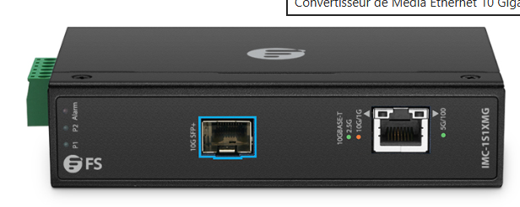
Figure 6 : Industrial 1x 100M/1G/2.5G/5G/10GBase-T RJ45 to 1x 10GBase-X SFP+ 10Gigabit Ethernet Media Converter.

3.6.9 Signal Amplifier system
The signal dedicated to trigger a camera is emitted by the frame grabber related to this camera. The emitted trigger signal is 3.3 V. On the other hand, from camera side, the voltage level of the input trigger signal is respectively 2 – 5 V (TTL) for the IR cameras and 11-30 V for the Visible ones. Furthermore, a cable up to 250 meters in length connects a camera with its frame grabber. Therefore, the signal attenuation due to the cable length has to be considered.
Concerning this last topic, it has been assessed that an emitted 5 V trigger signal for IR cameras and 24 V one for Visible camera are sufficient.
However, it is mandatory to transform the trigger signal emitted by the frame grabbers to reach these assessed voltage levels.
For this purpose, we propose to use an opto-coupler embedding board which receives, in input, a trigger signal from a frame grabber and a setup one from the camera power supply (see §3.6.4). This setup signal is at the expected voltage level considering the camera type and the cable length. When the trigger signal is received, the board commutes to the setup one.

Figure 7 : Signal transformation approach for camera triggering.

The big challenge is to find a board with a commutation frequency compliant with high frame rates acquisition.
We have selected the DST-1R4P-N-190551 model which is specified with a 20 kHz commutation frequency and is proposed in three different configurations for setup signal (5 V, 12 V and 24 V). We propose to use two 5 V boards for the IR cameras and two 24 V for the Visible ones.

Figure 8 : DST-1R4P-N-190551 board dedicated to camera trigger signal transformation.

However, the 20 kHz commutation frequency is not compliant with the maximal frame rate required for the High-Speed IR camera (30 kHz). Indeed, this signal amplifier system was identified before the need of a High-Speed IR camera became a requirement.
Furthermore, we have noted that a failure risk exists when the requested frame rate is above 10 kHz.
The board’s behaviour versus the commutation frequency would be assessed.

Therefore, If the board life is not acceptable, a home-made board will have to be developed.

